

Practices for Secure Software Report

Table of Contents
Document Revision History 3
Client 3
Instructions 3
Developer 4
1. Algorithm Cipher 4
2. Certificate Generation 4
3. Deploy Cipher 4
4. Secure Communications 4
5. Secondary Testing 4
6. Functional Testing 4
7. Summary 4
8. Industry Standard Best Practices 4

Document Revision History

Version | Date | Author | Comments
1.0 | 02/28/2026 | Chakira Lora Rosario

Client



Developer
Chakira Lora Rosario

Algorithm Cipher

To the security requirements for Artemis Financial, I recommend deploying the AES-256 (Advanced Encryption Standard) algorithm combined with SHA-256, which is a cryptographic hash function that generates a unique 256-bit signature for a given data string, ensuring that any unauthorized modification to the data can be immediately detected through a mismatch in the checksum value. This algorithm serves as a symmetric block cipher, meaning the same secret key is utilized for both the encryption of plaintext and the decryption of ciphertext.

“AES-256 encryption is extremely secure. It is the most secure encryption algorithm available today and is used extensively in government and military applications, as well as by businesses operating in highly regulated industries.” (Kiteworks, 2025). The security strength of this cipher relies in its 256-bit key length, which provides an vast number of possible combinations. Originally adopted by the U.S. government to protect "Top Secret" information, it is now the preferred choice for financial institutions to satisfy regulations like PCI DSS and GDPR. A critical component of this implementation is the use of random numbers and proper key management. For the encryption to remain secure, keys must be generated using a Cryptographically Secure Pseudo-Random Number Generator to ensure they possess high entropy and are not predictable in cyberattacks.

Certificate Generation

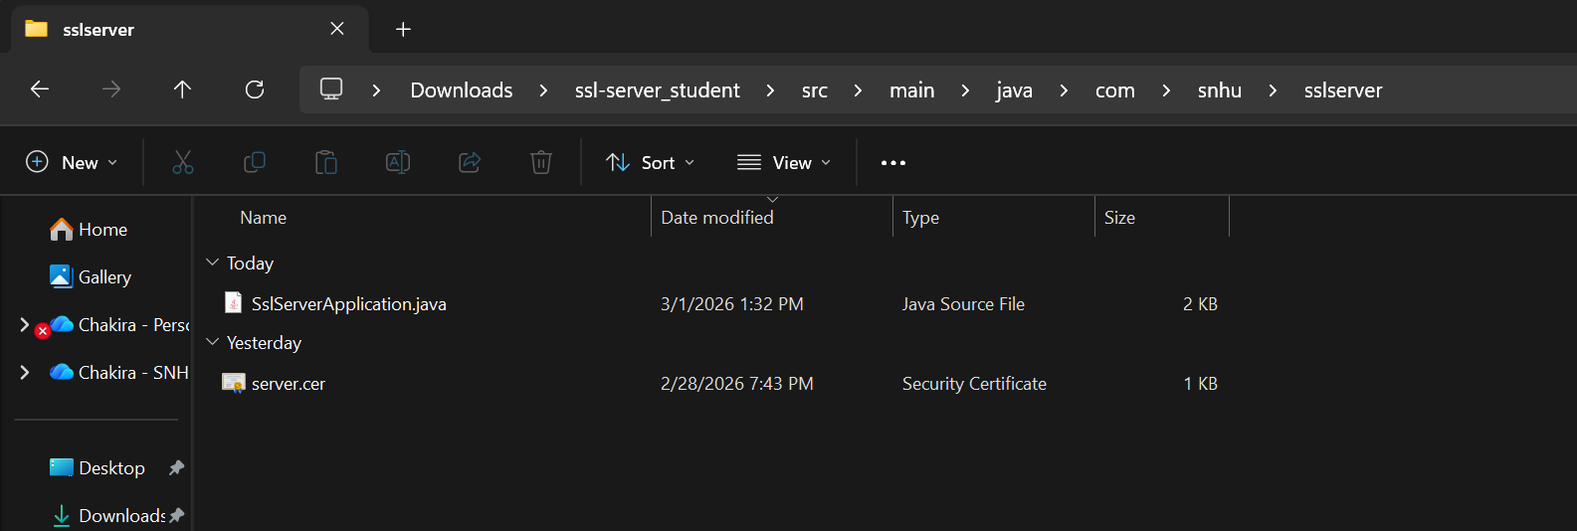

Deploy Cipher

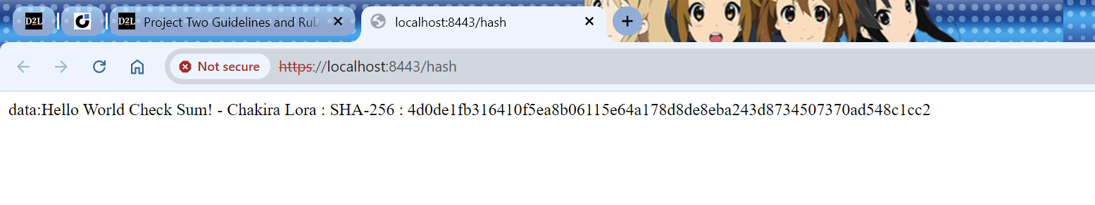

Secure Communications

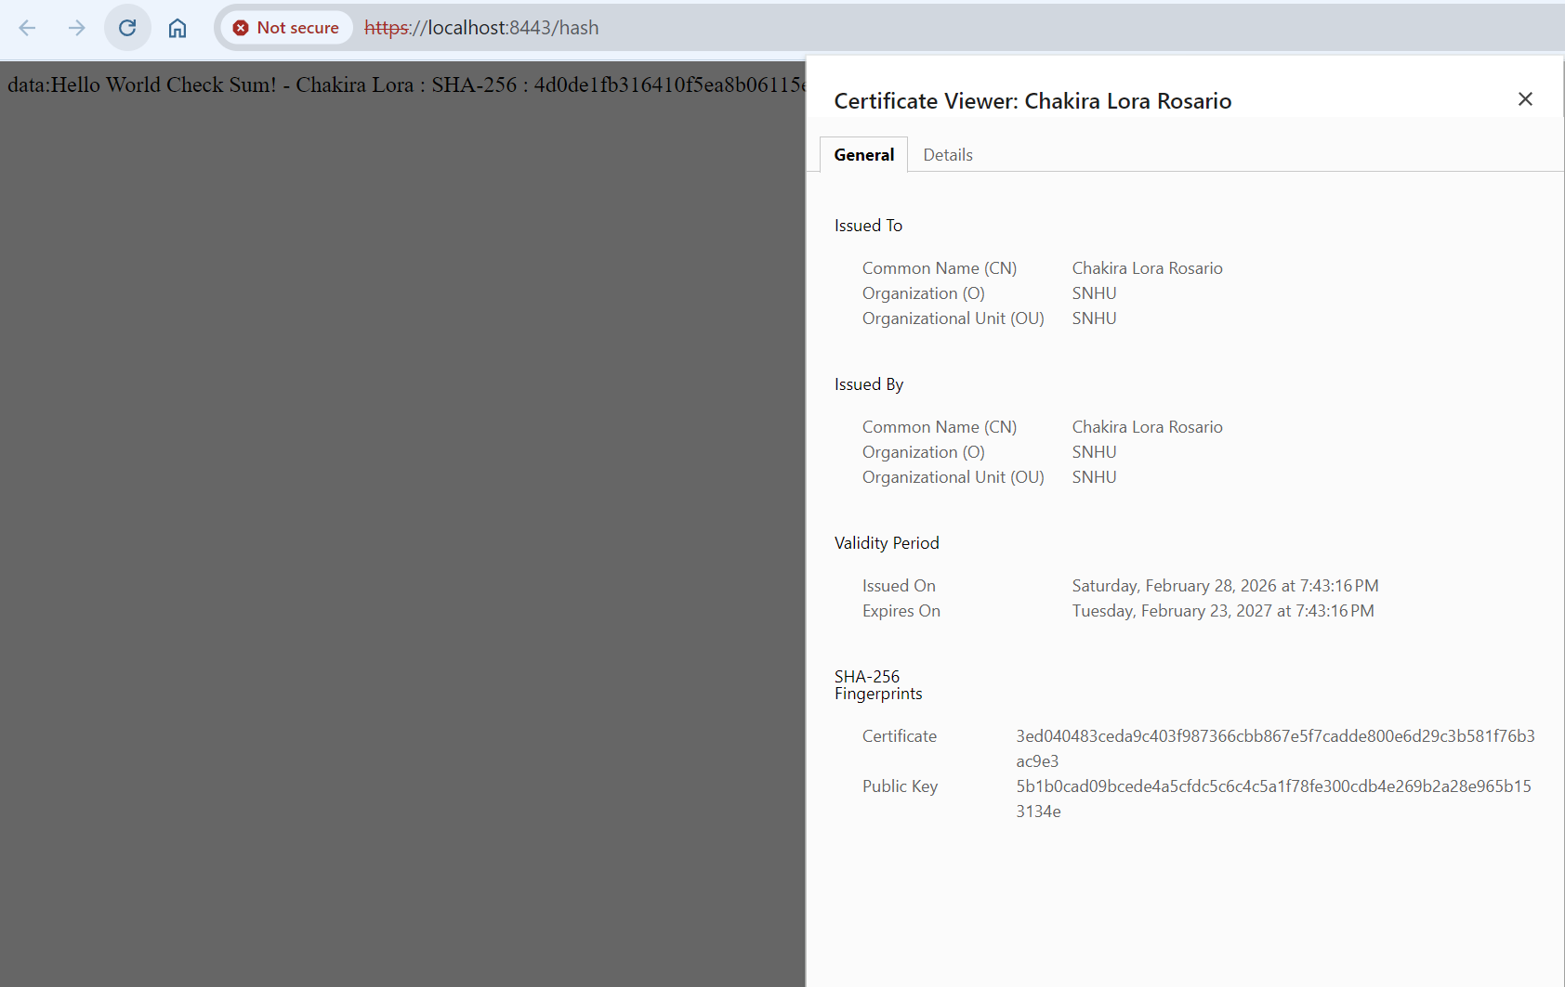

Secondary Testing

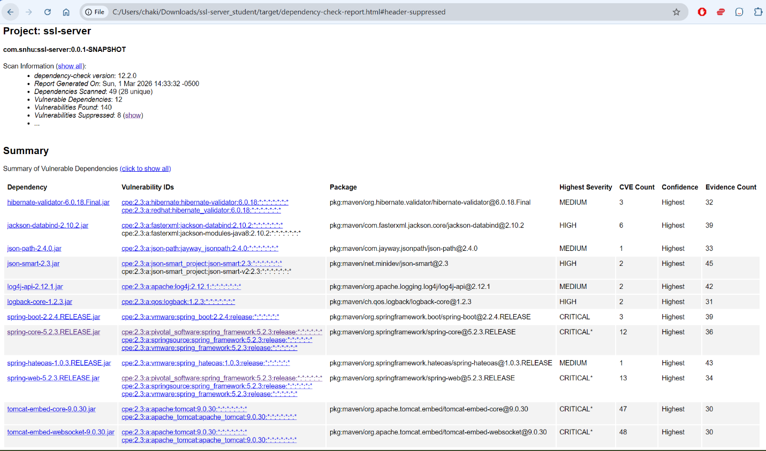

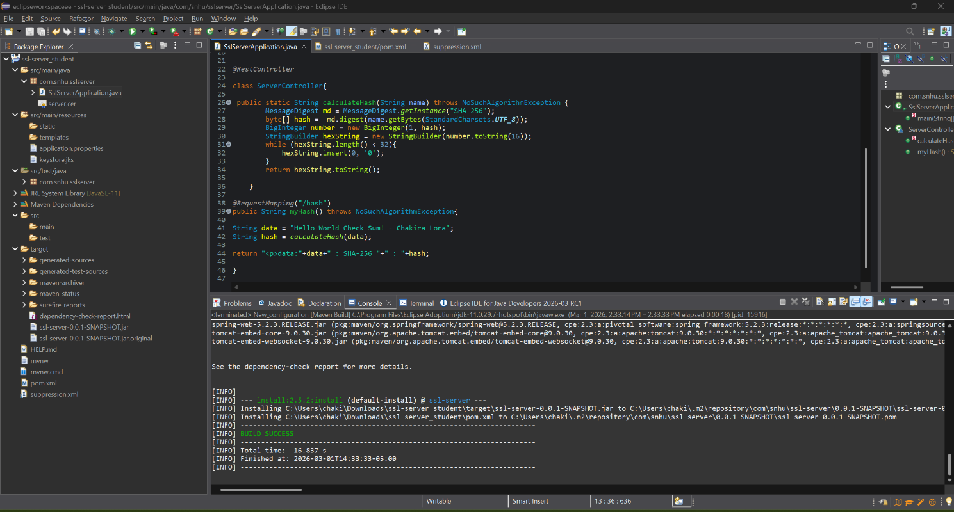

Functional Testing

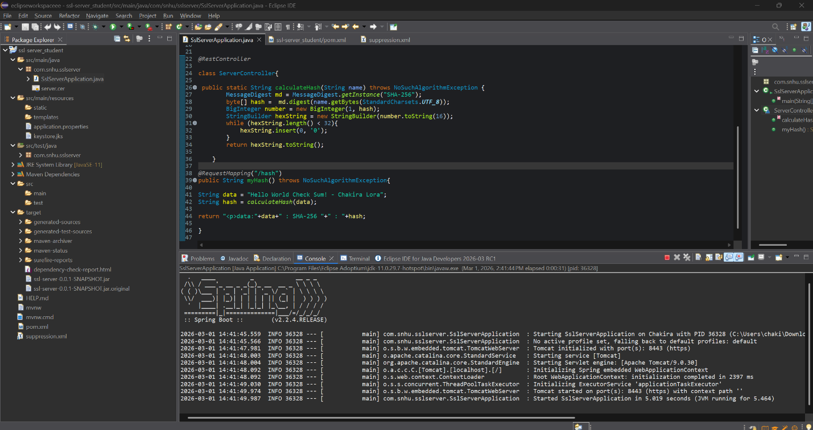

Summary

To start off, the principle of Defense in Depth was applied by not relying on a single security measure; instead, the system now uses both cryptographic hashing for integrity and TLS encryption for confidentiality. To maintain the existing security of the application, standard Java Cryptography Architecture (JCA) libraries were, unvetted encryption logic, which ensures that the math behind the security remains robust.

Additionally, secure key management practices were followed by using the Java Keytool to generate RSA keys. The use of the OWASP Dependency-Check tool allows for the identification of vulnerabilities in the software supply chain, ensuring that third-party libraries do not introduce "backdoor" risks. Applying these practices is vital to the company’s overall well-being because it directly mitigates the risk of costly data breaches and ensures compliance with strict financial regulations like PCI DSS.

Industry Standard Best Practices

By modifying the SslServerApplication.java file and implementing a custom REST controller, a secure endpoint was established at the /hash route. This route utilizes the SHA-256 cryptographic algorithm to generate a unique checksum for sensitive data strings, ensuring that any unauthorized changes to the data can be detected through hash verification.

Furthermore, the application’s communication layer was transitioned from a standard, unencrypted HTTP protocol to a secure HTTPS protocol on port 8443. This was achieved by integrating a self-signed JKS keystore within the Spring Boot framework through the application.properties configuration. By conducting static analysis with the OWASP Dependency-Check tool and performing functional testing to verify successful server execution, the software now complies with established security testing protocols and is significantly more resilient against modern cyber threats.

References
Kiteworks. (2025). Everything You Need to Know About AES-256 Encryption. Kiteworks. https://www.kiteworks.com/risk-compliance-glossary/aes-256-encryption/

